**Assignment**

Create Rails Application to display sample content in the frontend and a couple of buttons to generate the same content as pdf.

**Specifications:**

Rails >= 7.0.4

Ruby >= 3.2.3

Note:

Follow rails principle(i.e. Use the same html.erb to generate pdf).

You can use either wicked_pdf or grover gem to generate pdf.

Use a backend job(sidekiq) to create a pdf while sending pdf as email

Also write test cases to test functionality

Step1:

When a user enters “https://localhost:3000”, it should display the page below.

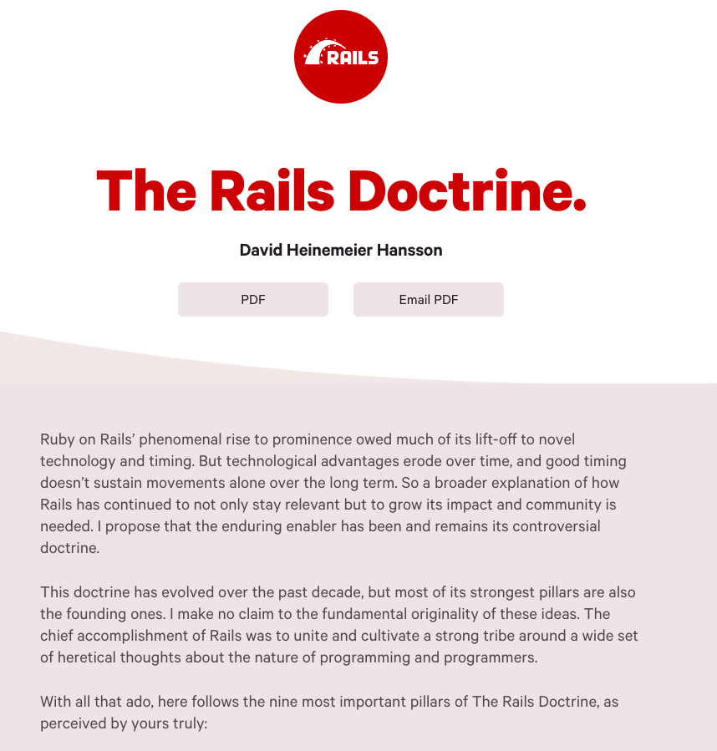

Step2:

When the user clicks on the “PDF” button, it should display the same content as pdf in another tab without buttons(“PDF” and “Email PDF”)

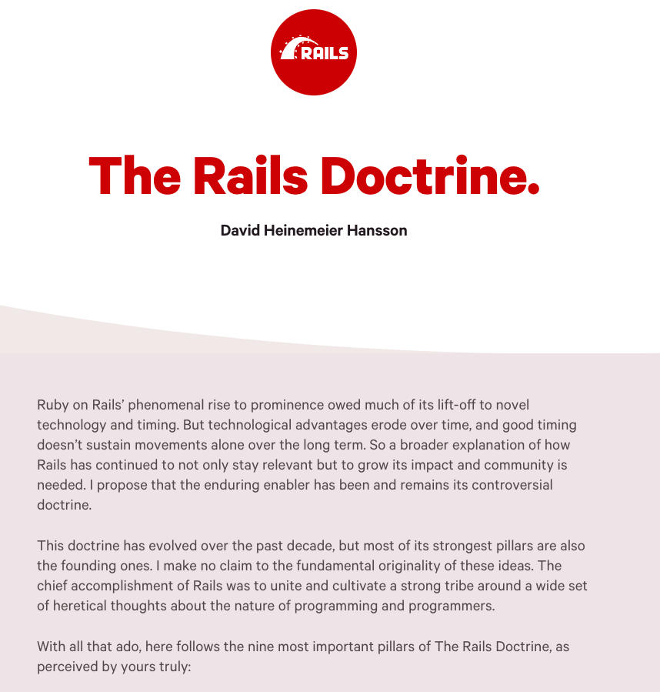

Step3:

When the user clicks on the “Email PDF” button, it should prompt and collect email and send page content as pdf via email.

